Keyboards

Pianotangenter

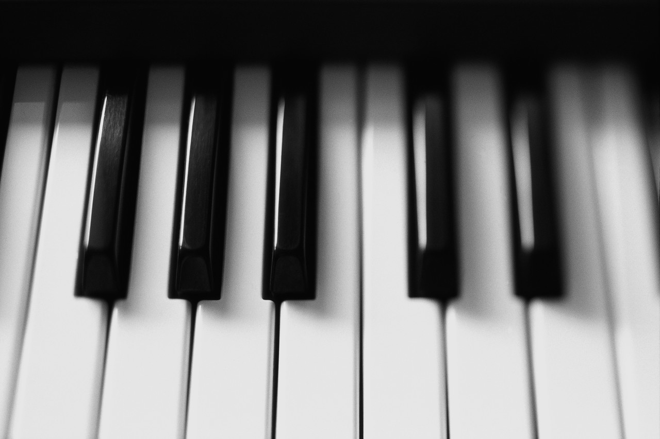

Piano

C:\Users\yhe1214.SIGTUNET\AppData\Local\Microsoft\Windows\Temporary Internet Files\Content.IE5\VMQWQE2N\MC900379333[1].wmf

Synth

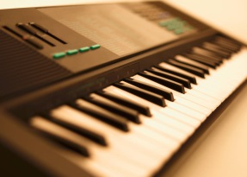

Flygel

C:\Users\yhe1214.SIGTUNET\AppData\Local\Microsoft\Windows\Temporary Internet Files\Content.IE5\KBV05U1I\MC900390660[1].wmf

Pedaler

Testa dig själv nästa sida:

Keyboards: Testa dig själv!

Vad kallas dessa på ett piano?____________________________



Vad heter det här instrumentet? ___________________________

C:\Users\yhe1214.SIGTUNET\AppData\Local\Microsoft\Windows\Temporary Internet Files\Content.IE5\VMQWQE2N\MC900379333[1].wmf

Vad heter det här instrumentet? ___________________________



Vad heter det här instrumentet? ___________________________

C:\Users\yhe1214.SIGTUNET\AppData\Local\Microsoft\Windows\Temporary Internet Files\Content.IE5\KBV05U1I\MC900390660[1].wmf

Vad kallas dessa?__________________________________