Rolling in the deep – Adele

Låtens ackordanalys:
Am G
Vers: II: / / / / I / / / / I / / / / I / / / / :II x 4

F G Em F
Refräng: II: / / / / I / / / / I / / / / I / / / / :II x 2
G Am
II: / / / / I / / / / :II x 4

Ackorden på gitarr: F
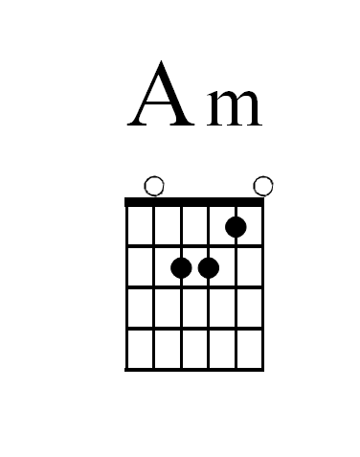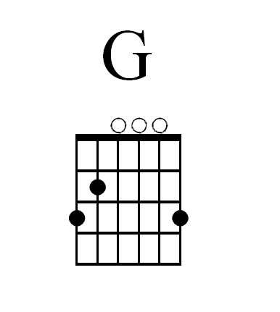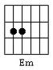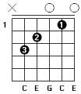
Ackorden på piano:
Am: A, C, E
G: G, B, D
F: F, A, C
Em: E, G, B

Räkna ut ackord på piano på egen hand:

- Durackord: räkna från grundtonen (här tonen G) och räkna halvtoner åt höger 4+ 3.
- Mollackord: räkna från grundtonen (här tonen A) och räkna halvtoner åt höger 3+ 4.

Am
There's a fire starting in my heart,
G
Reaching a fever pitch and it's bringing me out the dark

Am
Finally, I can see you crystal clear.
G
Go ahead and sell me out and I'll lay your ship bare.
Am
See how I leave, with every piece of you
G
Don't underestimate the things that I will do.
Am
There's a fire starting in my heart,
G
Reaching a fever pitch and it's bringing me out the dark

(Refräng)
F G Em
/ / The scars of your love, remind me of us.
F
They keep me thinking that we almost had it all

F G Em
/ / The scars of your love, they leave me breathless
E
I can't help feeling...

Am G
We could have had it all... (I wish you, never had met me)...
Am G
Rolling in the Deep (Tears are gonna fall, rolling in the deep)
Am G
Your had my heart... (I wish you)... Inside of your hand (Never had met me)
Am G
And you played it... (Tears are gonna fall)... To the beat (Rolling in the deep)

Vers 2

Am
Baby I have no story to be told,
G G
But I've heard one of you and I'm gonna make your head burn.
Am
Think of me in the depths of your despair.
G G
Making a home down there, as mine sure won't be shared.

F G Em
/ / The scars of your love, remind me of us.
F
They keep me thinking that we almost had it all
F G Em
/ / The scars of your love, they leave me breathless
E
I can't help feeling...

Am G
We could have had it all... (I wish you, never had met me)...
Am G
Rolling in the Deep (Tears are gonna fall, rolling in the deep)
Am G
Your had my heart... (I wish you)... Inside of your hand (Never had met me)
Am G
And you played it... (Tears are gonna fall)... To the beat (Rolling in the deep)

Vers 3
Am G
Am (hold)
Throw yourself through every open door (Whoa)
Count your blessings to find what look for (Whoa-uh)
Turn my sorrow into treasured gold (Whoa)
And pay me back in kind- You reap just what you sow.

Refräng x 3

